02.20 GOING CONCERN CONCLUSION

The following describes the functionality and features included in Probe Audit Premium+

Objective

The objective of this document is to document the engagement team's conclusion on the appropriateness of management's use of the going concern basis of accounting, and to record the audit opinion in relation to going concern.

The following key concepts of the Probe Audit Premium+ Methodology are set in this document:
- Evaluation of management’s going concern assessment (ISA 570)
- Determination of whether material uncertainty exists regarding the entity’s ability to continue as a going concern
- Impact of going concern conclusions on the form of the audit opinion

Document placement

Document 02.20 – Going concern conclusion can be found in the Finalisation folder in the Caseware document manager.
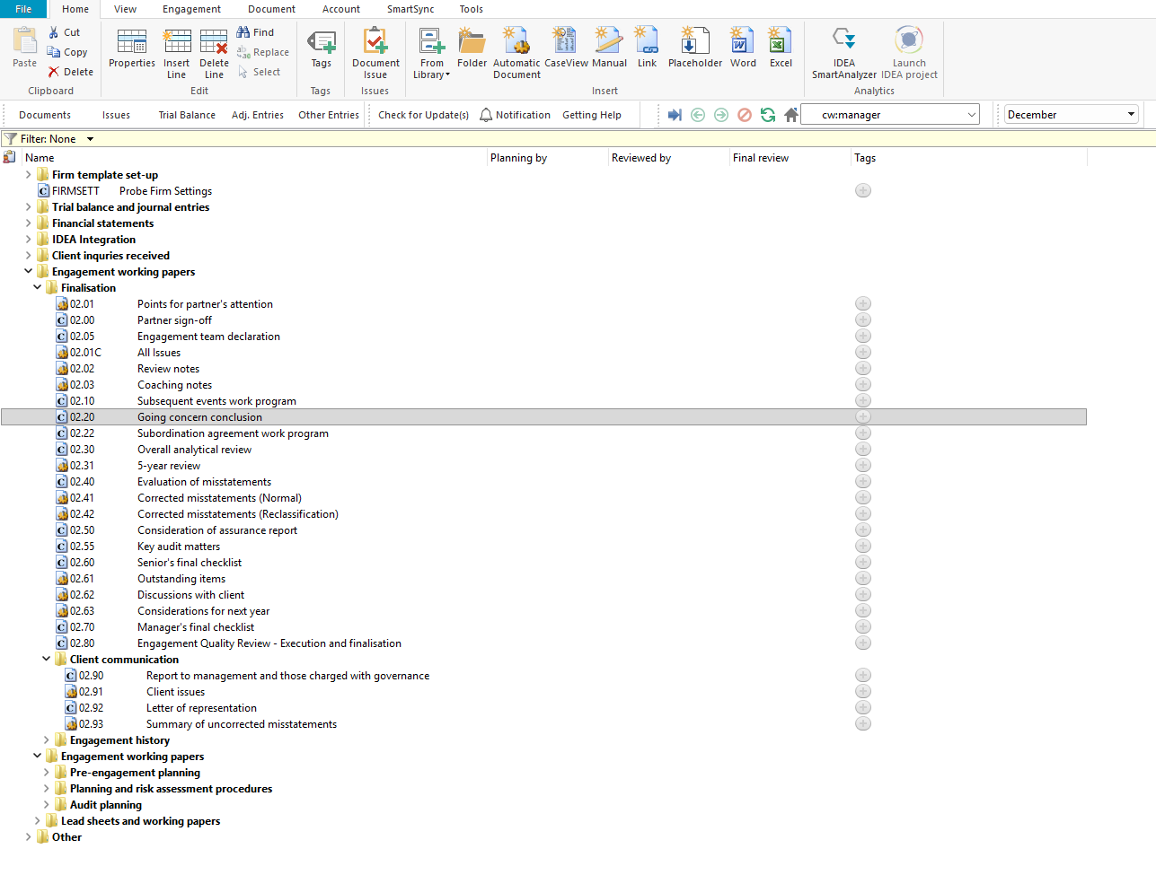

Document content

This document is designed to be a CaseView conclusion document. It presents pre-populated considerations for evaluating management's going concern assessment, a pre-populated conclusion and audit opinion, and a partner sign-off declaration.

This document addresses ISA 570 (Going Concern) by documenting the engagement team's evaluation of whether events or conditions exist that may cast significant doubt on the entity's ability to continue as a going concern, and recording the resulting conclusion and audit opinion.

This document is divided into different bookmarks in the document map to assist you with navigation:

Considerations

Conclusion

Partner sign-off
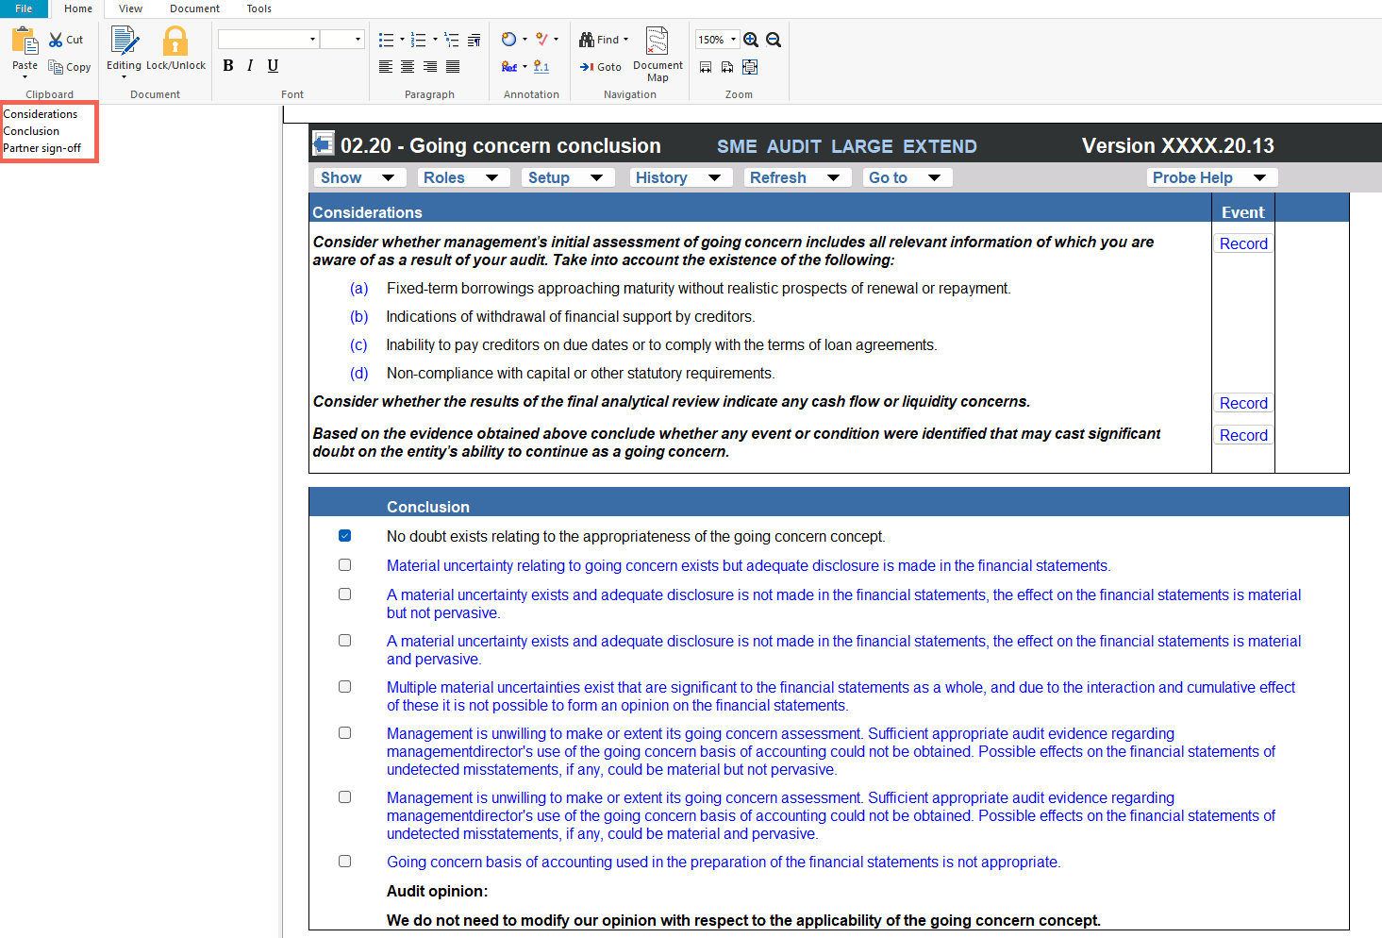

Layout
Column | Input Required | Outcome
Considerations
Considerations | No input is required in this column. Displays pre-populated considerations for evaluating management's going concern assessment. The considerations include: (a) fixed-term borrowings approaching maturity without realistic prospects of renewal or repayment, (b) indications of withdrawal of financial support by creditors, (c) inability to pay creditors on due dates or to comply with loan agreement terms, and (d) non-compliance with capital or other statutory requirements. Additional prompts address cash flow or liquidity concerns from the final analytical review and whether any event or condition may cast significant doubt on the entity's ability to continue as a going concern. | No impact on the engagement file. Provides the consideration framework for the engagement team's evaluation of going concern.
Event | Enter a description of any event or condition identified that may cast significant doubt on the entity's ability to continue as a going concern. | No impact on the engagement file. Records the going concern event or condition identified for the engagement file.
Conclusion
Conclusion statement | No input is required in this column. Displays the pre-populated conclusion: "No doubt exists relating to the appropriateness of the going concern concept." | No impact on the engagement file. Provides the default going concern conclusion for the engagement team's review.
Audit opinion | No input is required in this column. Displays the pre-populated audit opinion: "We do not need to modify our opinion with respect to the applicability of the going concern concept." | No impact on the engagement file. Provides the default audit opinion on going concern for the engagement team's review.
Partner sign-off
Partner declaration | No input is required in this column. Displays the pre-populated partner declaration confirming that the going concern procedures and evidence documented in planning and finalisation have been reviewed, and that sufficient and appropriate audit evidence has been obtained to support the conclusion and the report of the independent auditor in relation to the going concern basis of accounting. | No impact on the engagement file. Provides the partner's declaration framework for the going concern conclusion.

Document outcomes

The engagement team must consider the pre-populated going concern indicators and record any events or conditions identified that may cast significant doubt on the entity's ability to continue as a going concern. The considerations address fixed-term borrowings, withdrawal of financial support, inability to pay creditors, non-compliance with statutory requirements, cash flow or liquidity concerns, and the results of the final analytical review.

The engagement team must review the pre-populated conclusion and audit opinion on going concern. Where no doubt exists, the default conclusion and opinion are retained. Where events or conditions have been identified, the conclusion and audit opinion must be amended accordingly.

The engagement partner must review the partner sign-off declaration confirming that the going concern procedures and evidence have been reviewed and that sufficient and appropriate audit evidence has been obtained to support the going concern conclusion and the report of the independent auditor.

Group Audits

When the engagement type was selected as 'Group Audit Single' or 'Group Audit Multiple', the going concern conclusion applies to the group financial statements. The engagement team must consider going concern at both the group and component level and ensure the conclusion reflects the consolidated position of the group.

IN CONCLUSION

Features

The following features are available in the document:

Insert or delete a comment, see page F3

Guidance, see page F16

Freeze, see page F19

